Step 1: Flight Controller Designing
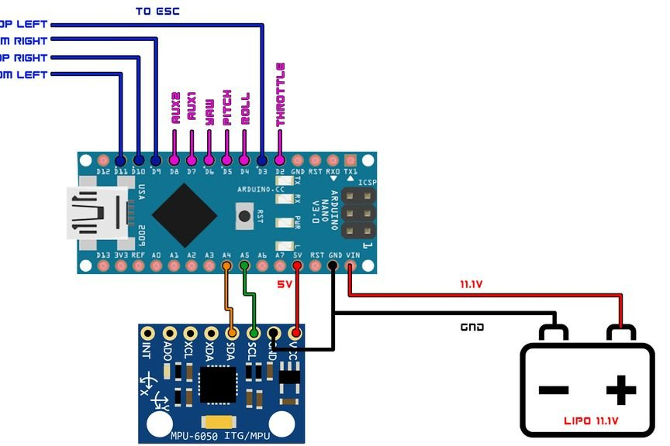
Here are the Schematics for the flight controller board. you can make one on your general purpose PCB or can Order a PCB from manufacturer as I did.
ESC Connections
- D3 << ESC 1 Signal Pin
- D9 << ESC 3 Signal Pin
- D10 << ESC 2 Signal Pin
- D11 << ESC 4 Signal Pin
Bluetooth Module Connections
- TX << RX
- RX << TX
MPU-6050 Connections
- A4 << SDA
- A5 << SCL
LED Indiacator
- D8 << Anode Leg of LED
Receiver Connections
- D2 << Throttle
- D4 << Elerons
- D5 << Ailerons
- D6 << Rudder
- D7 << AUX 1
Step 2: Building a Frame
I bought a DJI 450 frame and attached my motors and everything on it. You can see the video on how I did it.

Step 3: Attaching the Flight Controller Onto the Frame
Then finally attach the esc and receiver onto the board as shown in the schematics and everything is done!

